Project Development Phase Model Performance Test

Date | 10 February 2025
Team ID | SWTID-2026-2085
Project Name | Import Data using Transform Maps (Spreadsheet)
Maximum Marks

Model Performance Testing:
Project team shall fill the following information in model performance testing template.
s.no | Parameters | Description | Values | Screenshot
1. | Data Rendered | Data loaded into | Spreadsheet | 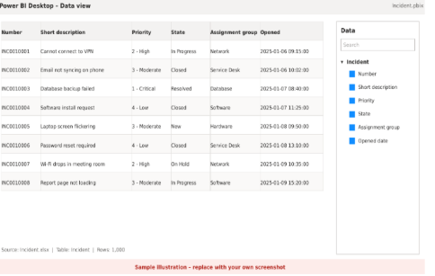
1. | Data Rendered | the report, | (.xlsx) loaded
1. | Data Rendered | including the | through a Data
1. | Data Rendered | source, tables | Source into an
1. | Data Rendered | and fields used. | Import Set table,
1. | Data Rendered | Attach a | then moved by a
1. | Data Rendered | screenshot of | Transform Map
1. | Data Rendered | the loaded data. | into the target
1. | Data Rendered |  | table (assumed:
1. | Data Rendered |  | Incident). Fields:
1. | Data Rendered |  | Number, Short
1. | Data Rendered |  | description,
1. | Data Rendered |  | Priority, State,
1. | Data Rendered |  | Assignment
1. | Data Rendered |  | group, Opened
1. | Data Rendered |  | date.
2. | Data | Cleaning and | Removed blank | 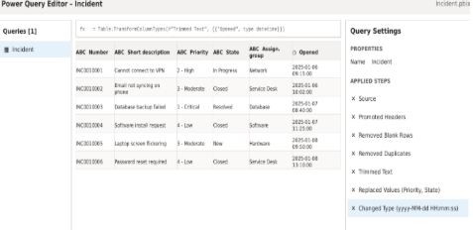
2. | Preprocessing | transformation | rows and
2. |  | steps applied | duplicates;
2. |  | before building | trimmed extra
2. |  | visuals, for | spaces; made
2. |  | example | Priority and
2. |  | removing nulls, | State values
2. |  | changing data | match the
2. |  | types or merging | ServiceNow
2. |  | tables. | choice lists;
2. |  |  | converted dates
2. |  |  | to yyyy-MM-dd
2. |  |  | HH:mm:ss;
2. |  |  | checked that
2. |  |  | column headers
3. | Utilization of Data Filters | Filters and slicers used at visual, page or report level to narrow down the data shown. | Slicers: Priority, State, Assignment group, Opened date range.  Page-level filter: State is not Cancelled. | 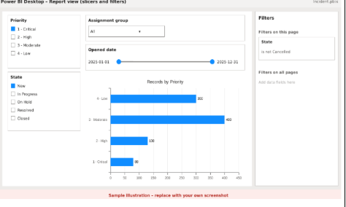
4. | DAX Queries Used | DAX measures, calculated columns or tables created for the report.  Mention the formulas used. | Total Records = COUNTROWS(I  ncident) High Priority = CALCULATE(C OUNTROWS(In  cident), Incident[Priority] IN {"1 - Critical",  "2 - High"}) Open Records = CALCULATE(C OUNTROWS(In  cident), Incident[State]  <> "Closed") % Closed = DIVIDE(CALCU LATE(COUNTR  OWS(Incident), Incident[State] = "Closed"), [Total Records]) | 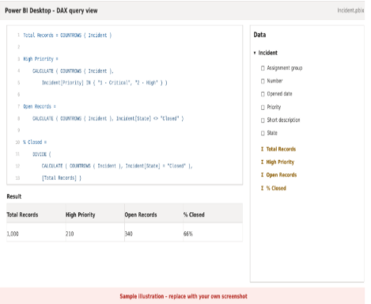
5. | Dashboard design | Layout of the dashboard and the visuals it contains.  Mention how many visualizations or graphs are used. | No of Visualizations / Graphs - 6 (3 KPI cards: Total Records, High Priority, Open Records; bar chart by Priority; donut chart by State; line chart of records opened per month) | 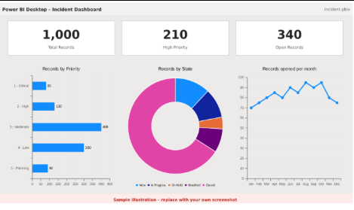
6. | Report Design | Layout of the report pages and the visuals it contains.  Mention how many visualizations or graphs are used. | No of Visualizations / Graphs - 3 (table of records, clustered bar by Assignment group, line chart of trend over time) | 